Phase 5

Lesson 3

**Initialize a Volume Restored from a Snapshot on Linux**

Steps:

1. Selecting the snapshot

2. Restoring volume from the snapshot

**Step 1:** Selecting the snapshot

* Go to EC2 dashboard in EBS and click on *Snapshot*

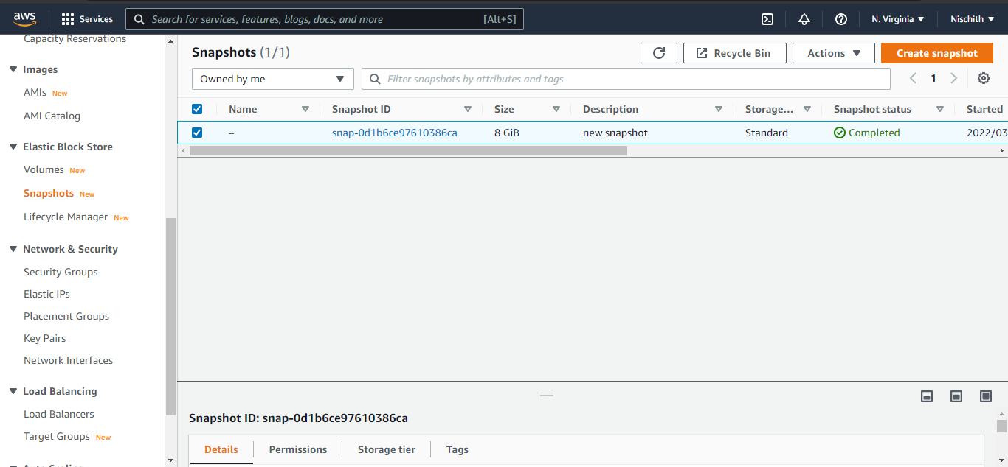

**Step 2:** Restoring volume from the snapshot

* Select the snapshot and click on Action to create volume

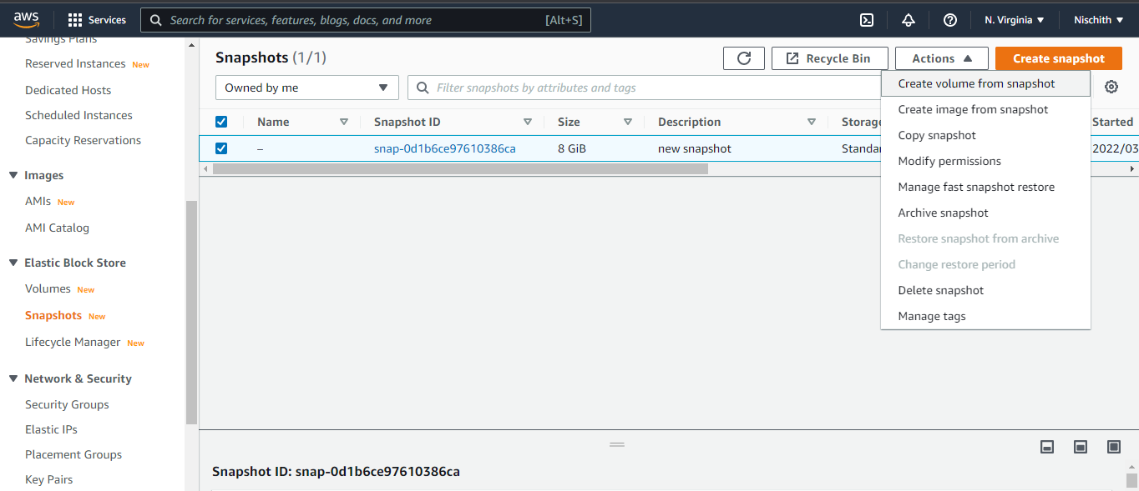

* You can specify the key and value to identify the volume

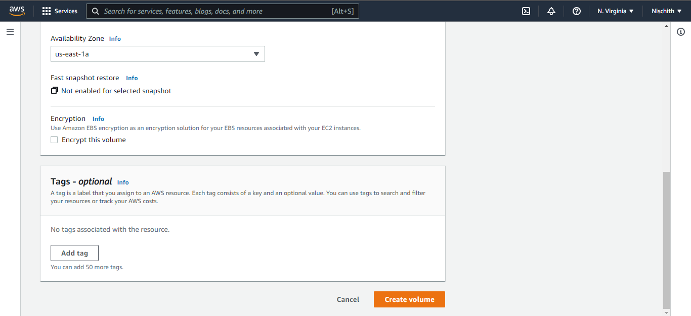

* Restore the volume from the snapshot

